IVTECH – LICENSE & BI DASHBOARD WEB APP

Software Architecture Specifications

Version 1.0.0

Revision History

Date | Doc Version | Author | Status(Created/Updated/Reviewed/Approved/Verified)  In case of updated- Mention what has been updated? give change/issue/req id as ref.
20-03-2025 | 1.0.0 | Parth Jotangiya | Created

Table of Contents
1. Introduction 4
1.1 Design Scope and Objectives 4
1.2 Design Deliverables 4
1.3 Definitions, Acronyms, and Abbreviations 4
1.4 References 4
2. Architectural Representation 4
1.5 Application Architecture 4
1.6 Application Prototype/Screen Designs and Flow 4
1.7 Class Diagram 4
1.8 ER Diagram 5
3. Architectural Goals and Constraints 5

Introduction

Design Scope and Objectives
This document is to give overview of technical architecture followed in License & BI Dashboard Web Application project.
Technology used in this project is:
- Frontend: React.js
- Backend: .NET Core + Web API
- Database: MongoDB

Design Deliverables
- SPEC INDIA will be delivering below items as part of project deliverables:
- System Requirements Specification (SRS) Document.
- UI/UX (Figma) Design.
- Source Code files.

Definitions, Acronyms, and Abbreviations

Definitions, Acronyms and Abbreviations
React.js | A JavaScript library for building user interfaces, particularly single-page applications (SPAs) with component-based architecture.
JSX | JavaScript XML, a syntax extension for JavaScript used in React to describe UI elements in a syntax like HTML.
Component | A reusable UI element in React that can be a class-based or functional component.
State | An object that stores dynamic data in a React component, influencing its rendering.
Props | Short for "Properties," used to pass data between React components.
MongoDB | A NoSQL database that stores data in JSON-like documents, known for its flexibility and scalability.
Collection | A group of MongoDB documents, like a table in relational databases.
Document | A single record in a MongoDB collection, stored in BSON format.
Schema | A structure defining the shape of documents in MongoDB, typically enforced using Mongoose in Node.js applications.
.NET Core Web API | A cross-platform, open-source framework for building RESTful web services using C# and .NET Core.
Controller | A class in .NET Core Web API that handles HTTP requests and responses.
Middleware | Software components in .NET Core that process HTTP requests and responses in a pipeline.
Entity Framework (EF) Core | An Object-Relational Mapper (ORM) for .NET Core, enabling database operations using C#.
DTO (Data Transfer Object) | A design pattern in .NET used to transfer data between layers of an application.
REST API | Representational State Transfer API, a web service architecture used for communication between clients and servers.
JWT (JSON Web Token) | A compact, URL-safe token used for authentication and authorization in web applications.

References
- Based on discussions and conclusions regarding the BI Dashboard Web Application with Bala & Team, the SPEC Team has applied their expertise to create a fresh and modern Figma design which is also approved by Bala & Team.
- Please find the attached link below for the Light Theme:
  - Click here to Open newly created Figma for Light Theme
- Please find the attached link below for the Dark Theme:
  - Click here to Open newly created Figma for Dark Theme
- Based on discussions and conclusions regarding the License Web Application with Bala & Vijeesh, the SPEC Team has applied their expertise to create a fresh and modern Figma design which is also approved by Bala & Vijeesh. Please find the attached link below:
  - Click here to Open newly created Figma Design for License Web Application

Architectural Representation
- The image below represents the flow of the entire system architecture, including all applications such as the License Web Application, BI Dashboard Web Application, and the backend middleware for both applications:

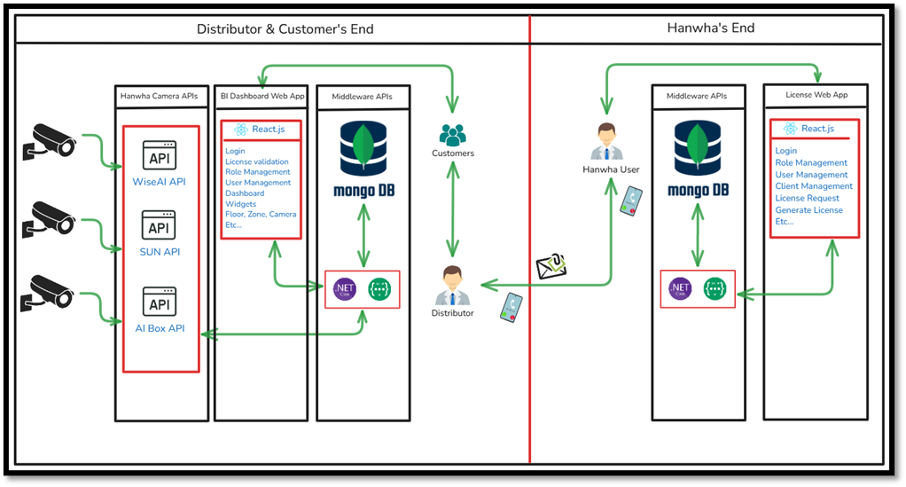

- The architecture below represents the flow of Backend Development Using .NET Core + Web API:

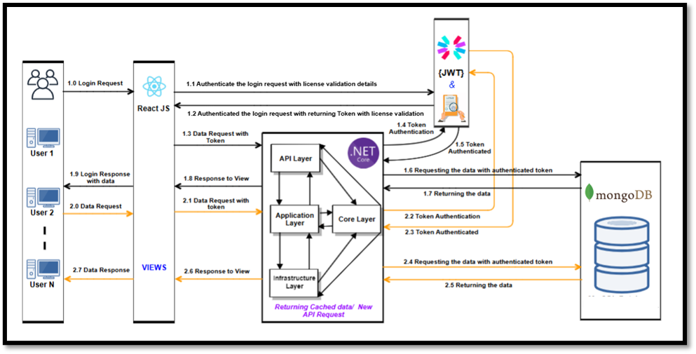
- The architecture below represents the flow of Frontend Development Using React.js Technology:

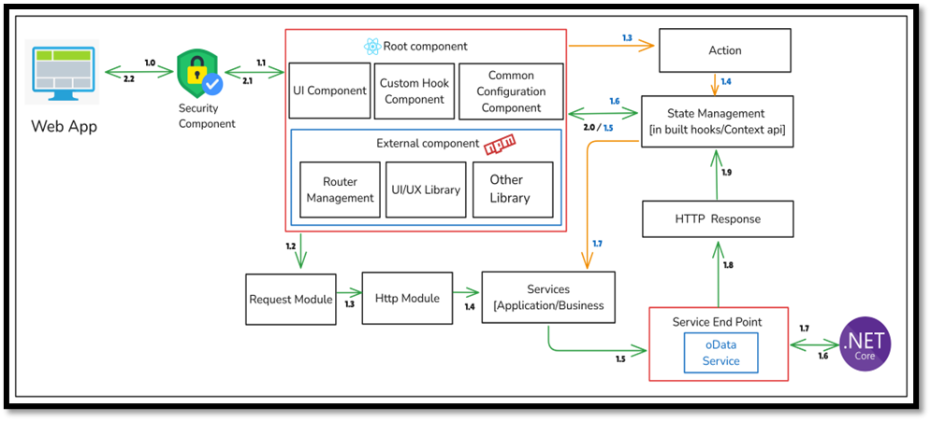

Application Architecture
Clean architecture.

Application Prototype/Screen Designs and Flow
Already mentioned in the reference section

Class Diagram
N/A

ER Diagram
N/A

Architectural Goals and Constraints
N/A

